Assume node A is transmitting to node B and B is receiving from node A. Then the following statements apply (it’s all about the receiver)
- Node A can not receive from any node while it is transmitting
- Any node within range of node A can not receive from node A if it is not the intended recipient
- Any node within range of A will not be able to receive from any other node while A is transmitting
- Node B can not receive from any other node while it is receiving from node A
- Any nodes within range of node B can not receive from node B as B is unable to send while receiving from node A
- Any node within range of B can not send to any other node due to risk of collision with node B (receiving from node A)
Given the following:
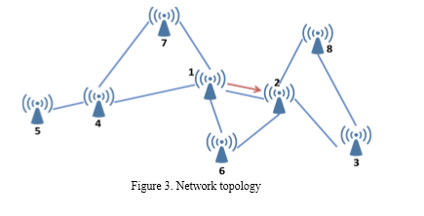
Let 1 = Node A and 2 = Node B. Going through the receivers in Node order:
Sender | Receiver | Y/N | Reason
4 | 1 | N | (i)
6 | 1 | N | (i)
7 | 1 | N | (i)
3 | 2 | N | (iv)
6 | 2 | N | (iv)
8 | 2 | N | (iv)
2 | 3 | N | (v)
8 | 3 | N | (vi)
1 | 4 | N | (ii)
5 | 4 | N | (iii)
7 | 4 | N | (iii)
4 | 5 | Y | 5 can receive as it has no dependency on 1 or 2
1 | 6 | N | (ii)
2 | 6 | N | (v)
1 | 7 | N | (ii)
4 | 7 | N | (iii)
2 | 8 | N | (v)
3 | 8 | N | (vi)

